1. **Create a Database:**

* Create Table DummyTBL (ID int, Name varchar(50));
* Add many records to the tables (data not necessary to be meaningful)

1. **Create a search form which allow user to display data by given page index (user may choose the page index from the pagger) and page size (this can be configured) :**

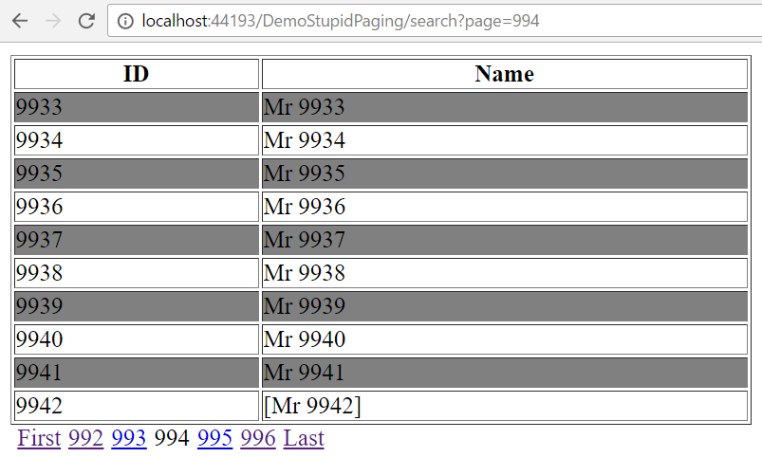

* Using JSTL to display data in JSP
* Create a pager (which display page indexes (as hyperlinks) at the end of the page) as a custom tag (take page index and page size as parameters)